**Stationarity diagnostics:**

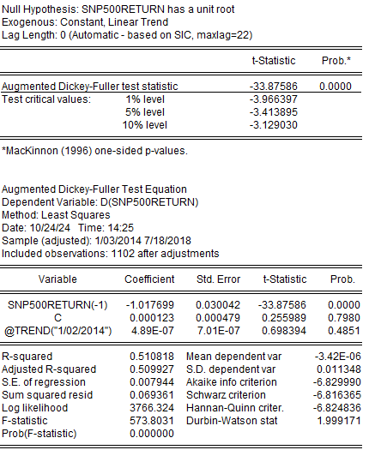

Since p-value = 0.0000 which is less than 0.05, we reject null hypothesis. It is concluded that SNP500 return does not have a unit root.

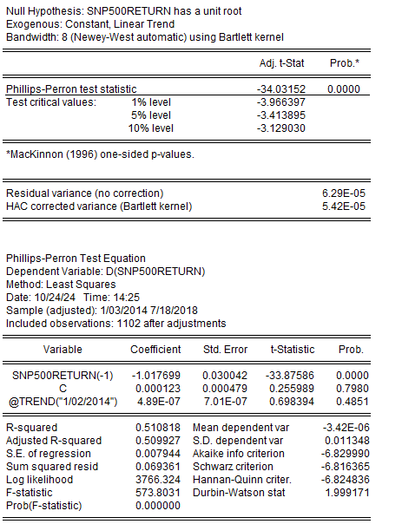

Since p-value = 0.0000 which is less than 0.05, we reject null hypothesis. It is concluded that SNP500 return does not have a unit root.

Since p-value = 0.3675 which is more than 0.05, we fail to reject null hypothesis. It is concluded that SNP500 does have a unit root.

Since p-value = 0.4520 which is more than 0.05, we fail to reject null hypothesis. It is concluded that SNP500 does have a unit root.

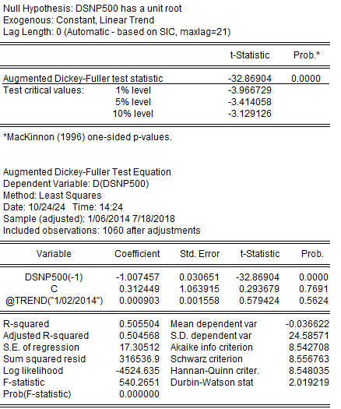Since the SNP500 data is non-stationary, differencing is applied to the data.

Since p-value = 0.0000 which is less than 0.05, we reject null hypothesis. It is concluded that dSNP500 does not have a unit root.

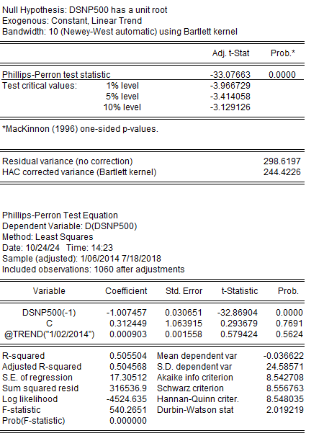

Since p-value = 0.0000 which is less than 0.05, we reject null hypothesis. It is concluded that SNP500 return does not have a unit root.

**ARMA MODEL:**

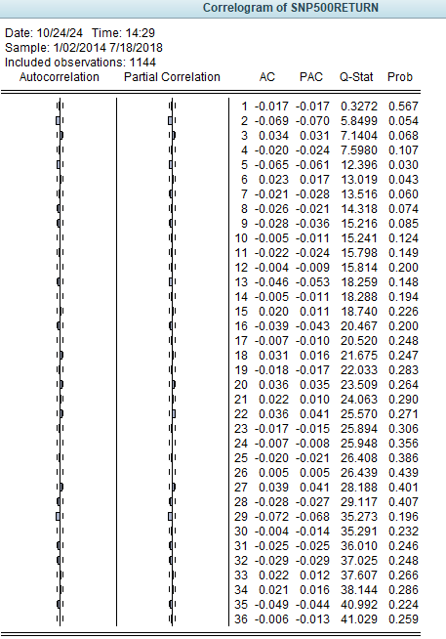

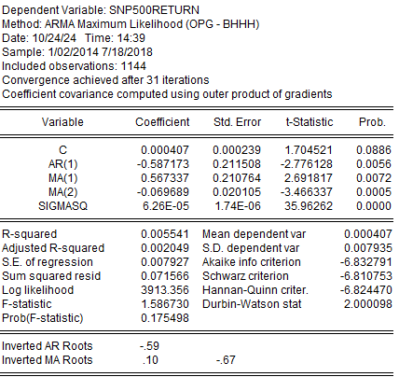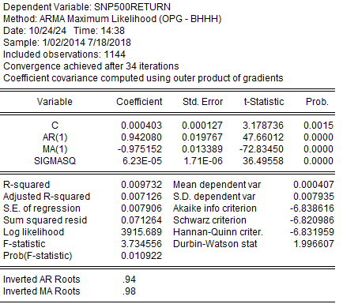ARMA(1,1) [okay] ARMA(1,2) [not okay]

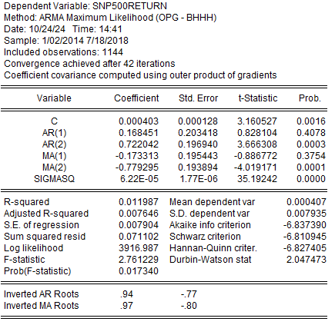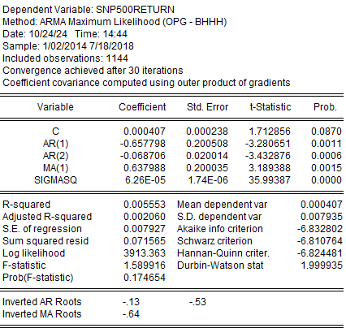

ARMA(2,1) [not okay] ARMA(2,2) [not okay]

**For SNP500 RETURN, we choose ARMA (1,1) model as all the variables are significant (probability <0.05) and have lowest AIC and SIC when compared to other models (the difference does not differ significantly).**

ARIMA (1,1,1) [okay] ARIMA (1,1,2) [not okay]

ARIMA (2,1,1) [not okay] ARIMA (2,1,2) [not okay]

**For DSNP500, we choose ARIMA (1,1,1) model as all the variables are significant (probability <0.05) and have lowest AIC and SIC when compared to other models (the difference does not differ significantly).**

**DIAGNOSTIC TESTS**

**FOR SNP500 RETURN ARMA (1,1):**

*Ljung-Box Q Test*

H0: No residual autocorrelation.

H1: Residual autocorrelation is present.

At lag 10, the probability is 0.426 which is greater than 0.05, we fail to reject null hypothesis. Therefore, there is no significant autocorrelations. Thus, residuals resemble white noise.

*Durbin-Watson*

Durbin-Watson Stat is 1.996607 which is close to 2, which suggests no significant autocorrelation in the residuals.

*White Test*

H0: Homoscedasticity of residuals.

H1: Heteroscedasticity of residuals.

The probability (F-stat) is 0.0000 which is less than 0.05, thus, we reject null hypothesis. Therefore, heteroscedasticity of residuals is exhibited in the model indicating variance of residuals changes across observations.

**FOR DSNP500 ARIMA (1,1,1):**

*Ljung-Box Q Test*

H0: No residual autocorrelation.

H1: Residual autocorrelation is present.

At lag 10, the probability is 0.102 which is greater than 0.05, we fail to reject null hypothesis. Therefore, there is no significant autocorrelations. Thus, residuals resemble white noise.

*Durbin-Watson*

Durbin-Watson Stat is 2.003312 which is close to 2, which suggests no significant autocorrelation in the residuals.

*White Test*

H0: Homoscedasticity of residuals.

H1: Heteroscedasticity of residuals.

The probability (F-stat) is 0.0000 which is less than 0.05, thus, we reject null hypothesis. Therefore, heteroscedasticity of residuals is exhibited in the model indicating variance of residuals changes across observations.

**Which model to choose?**

When comparing both models ARMA (1,1) for SNP500 RETURN and ARIMA (1,1,1) for DSNP500, both models:

1. Has residuals which resemble white noise/random (Ljung Box Test)
2. Has no significant autocorrelation in residuals (Durbin-Watson Test)
3. Suffers from heteroscedasticity of residuals (White Test)
4. Contains significant relationship between all explanatory variables (p-value less than 0.05)
5. Are stationary

However, the model ARMA (1,1) for SNP500 RETURN are chosen due to the lower value of AIC = -6.838616 and SIC = -6.820986 when compared to ARIMA (1,1,1) DSNP500 with AIC = 8.533990 and SIC = 8.540652.